MICROSOFT PURVIEW
Information Protection
Scanner Deployment Guide
Customer-ready installation, authentication, validation, and first-scan instructions

Purpose
Use this guide with the companion deployment script to prepare the environment, install the scanner, configure authentication, validate readiness, and run the first discovery scan.
Audience: Microsoft 365 compliance administrators, security administrators, Windows Server administrators, and SQL administrators.

Document status: Customer presentation copy
Guidance reviewed against Microsoft Learn: August 2026
IMPORTANT
Screenshots are examples from a lab environment. Use your organization’s server names, accounts, tenant values, and approved security processes.

A | How to use this guide
Complete the sections in order. The deployment worksheet should be approved before the installation window begins. Start in discovery mode and review results before enabling enforcement.
- 1. Scope and scanner behavior
- 2. Roles and responsibilities
- 3. Prerequisites and readiness checklist
- 4. Deployment worksheet
- 5. Portal configuration
- 6. Run the deployment script
- 7. Configure app authentication
- 8. Optional Azure Rights Management super user
- 9. Validate installation and run the first scan
- 10. Reporting, operations, and troubleshooting
- Appendix A. Command reference
- Appendix B. Microsoft documentation
CUSTOMER DECISION GATE
Do not enable automatic labeling or protection until discovery results, exclusions, repository permissions, and rollback expectations have been reviewed and approved.

1 | Scope and scanner behavior
The Microsoft Purview Information Protection scanner runs as a Windows service and can discover, classify, and protect supported files in on-premises repositories. Supported repository scenarios include UNC paths for network shares and supported SharePoint Server document libraries or folders. It is not a real-time monitor; it crawls repositories on a configured cycle.
Discovery versus enforcement
Operating mode | What it does | Recommended use
Discovery | Inspects content and produces reports without changing files. | Begin here. Validate detections, scope, permissions, and performance.
Enforcement | Applies labels and optional protection according to configured policy. | Enable only after customer approval and successful discovery validation.
Relabel / full rescan | Reprocesses content based on the configured options. | Use deliberately because it can increase processing and file-change volume.

2 | Roles and responsibilities

Role | Typical responsibility | Required during
Purview administrator | Create the scanner cluster and content scan job; publish labels; review scan configuration. | Planning, portal configuration, validation
Windows Server administrator | Prepare the host, install software, run the script as administrator, manage the service. | Installation and operations
SQL administrator | Provide the SQL instance and installation permissions; validate database access. | Installation and database troubleshooting
Identity administrator | Create or approve the app registration, API permissions, client secret, and admin consent. | Authentication
Repository owner | Approve scope and grant the scanner account required repository permissions. | Readiness and pilot
Security / compliance owner | Approve discovery findings and any transition to enforcement. | Pilot exit and production rollout

LEAST PRIVILEGE
Separate installation-time elevation from steady-state scanner permissions. Store secrets only in the customer-approved vault and record the expiration owner.

3 | Prerequisites and readiness checklist
Confirm every item before the change window. The script can automate portions of the deployment, but it does not replace tenant, network, identity, SQL, and repository approvals.
☐ Scanner host
64-bit Windows Server 2025, 2022, 2019, or 2016; Server Core and Nano Server are not supported. Minimum planning baseline: 4 cores, 8 GB RAM, and approximately 10 GB free disk space.
☐ Network
Reliable access to repositories and required Microsoft service endpoints over HTTPS 443. Proxy and TLS inspection behavior must be validated.
☐ SQL Serve
Identify the supported SQL instance. The installation operator needs local administrator rights on the scanner server and sysadmin rights on the selected SQL instance for Install-Scanner.
☐ Service account
Use a dedicated domain account for the Windows service. Grant repository permissions based on the operating mode and ensure the account can log on as a service.
☐ Labels and policy
Publish at least one sensitivity label and policy to the delegated scanner account. Automatic labeling criteria are required when the scanner is expected to label by content.
☐ Repository paths
Use approved UNC paths for network shares. For SharePoint, use supported SharePoint Server libraries or folders. Do not list SharePoint Online as a scanner repository.
☐ Administrative access
Confirm who can create app registrations, create credentials, grant tenant-wide admin consent, and administer Azure Rights Management if super user support is selected.
☐ Change control
Document the pilot scope, maintenance window, discovery-only starting state, rollback owner, and production approval criteria.

4 | Deployment worksheet
Complete and approve this worksheet before running the script. Do not place passwords or secret values in this document.
Item | Customer value | Owner / approval
Scanner server
SQL Server instance
Scanner cluster name
Windows service account (DOMAIN\user)
Delegated scanner UPN
Pilot repository UNC path
Purview administrator
Identity / consent administrator
RMS administrator, if applicable

CREDENTIAL HANDLING
Collect passwords interactively when prompted. Never paste client secrets into email, tickets, chat, screenshots, or this worksheet.

5 | Portal configuration
- Sign in to the Microsoft Purview portal with an approved administrative role.
- Open Settings > Information Protection > Information Protection scanner.
- Create a scanner cluster with a meaningful, stable name. Record the exact cluster name in the worksheet.
- Create a content scan job and add the approved pilot repositories.
- Start with enforcement disabled. Configure the file types, information types, schedule, and repository overrides according to the pilot plan.
- Confirm that the delegated scanner account is included in the applicable sensitivity label publishing policy.

6 | Run the deployment script
Run the customer-approved script from an elevated Windows PowerShell session on the scanner server. Close other PowerShell sessions that have loaded older versions of the client module.
cd C:\Scripts (or where ever the script has been saved to.)
.\Install-PurviewScanner.ps1
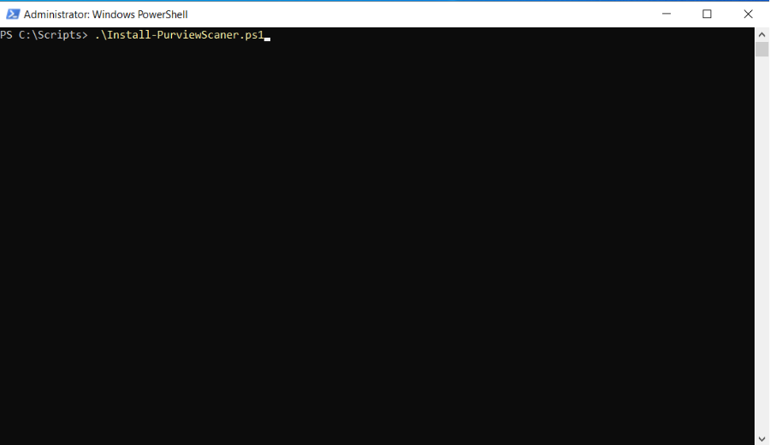
Figure 1. Start the deployment script from an elevated PowerShell session.

Install or verify the client
If the client is not detected, the script opens the official download page. Install the production PurviewInfoProtection.exe package, close the installer, return to PowerShell, and press Enter.
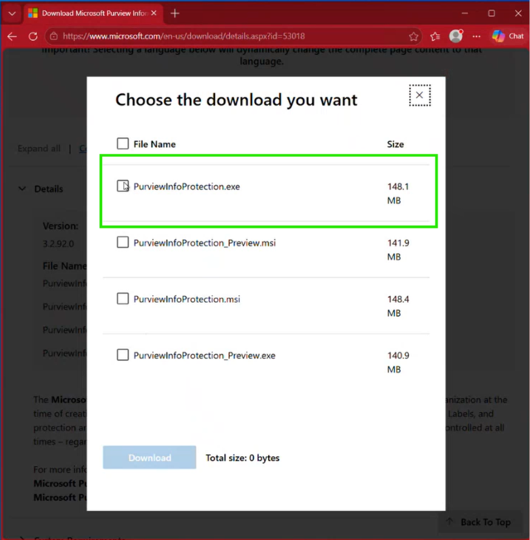
Figure 2. Script prompt shown when the information protection client is not detected and opens site to download client.

Trusted sites and interactive label validation
- When prompted, choose Y to add the recommended Microsoft authentication URLs to Trusted Sites, if approved by your security policy.
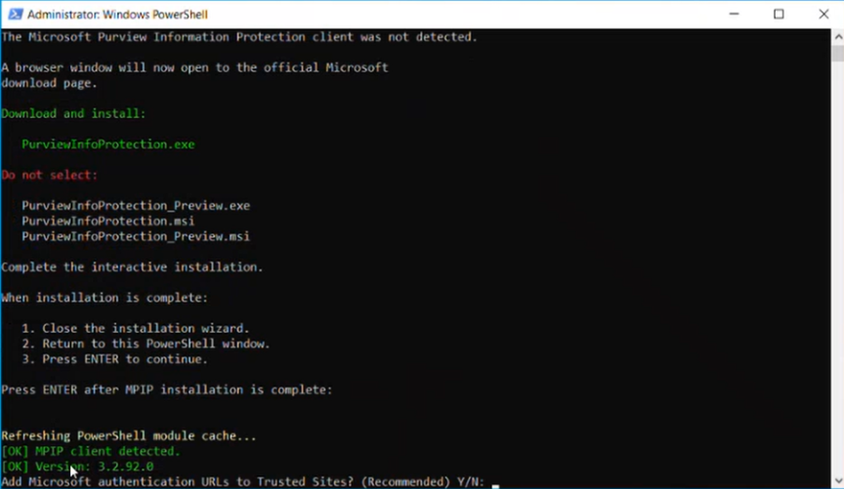
Figure 3. Prompt to add Microsoft Authentication URLs and URLs needed for the scanner service to connect to Purview.

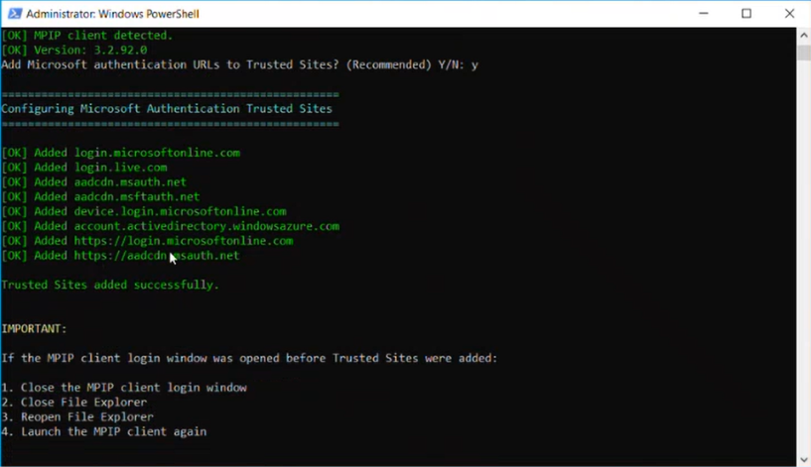
Figure 4. List of URLs added to Trusted Sites.

Open file labeler to login with Service Account and validate policy/labels
- Allow the script to create and open the validation file in the Information Protection File Labeler.
- Sign in as the delegated scanner account and confirm that expected sensitivity labels are displayed.
- Close the File Labeler and return to the script. Select Y only when the validation succeeds.
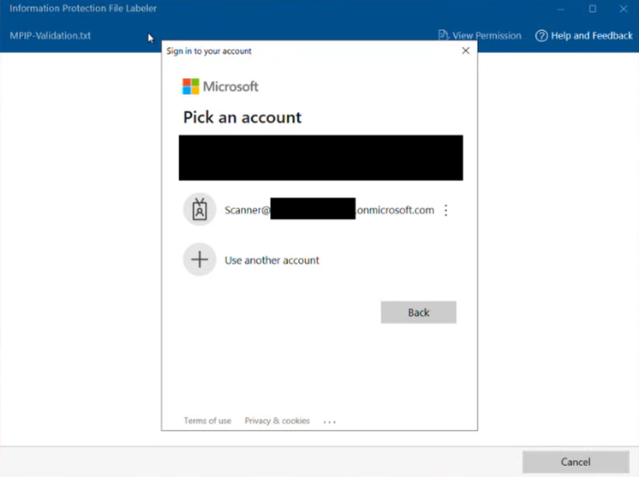
Figure 5. Login with the Scanner Service account email address to download label policy.

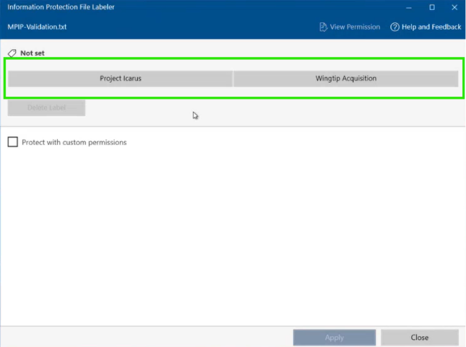
Figure 6. Confirm that the delegated scanner account can see the expected labels.

IF LABELS DO NOT APPEAR
Stop and verify label publication, account targeting, authentication, and policy download. Do not continue to scanner authentication until this validation is successful.
7 | Install the scanner service and database
- Enter the SQL Server instance exactly as recorded in the worksheet, for example SQLSERVER1\SQLEXPRESS.
- Enter the exact scanner cluster name created in the Purview portal.
- Review the values displayed by the script and choose Y to continue.
- When the secure credential prompt appears, enter the dedicated Windows service account in DOMAIN\user format and its password.
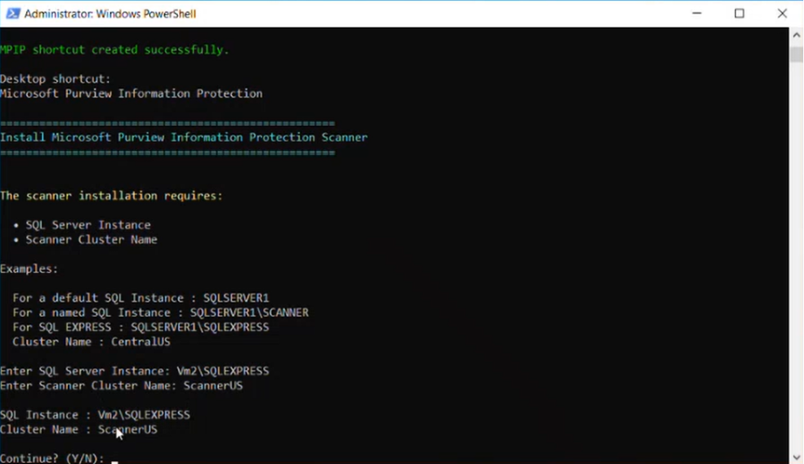
Figure 7. Provide the SQL instance and scanner cluster name.
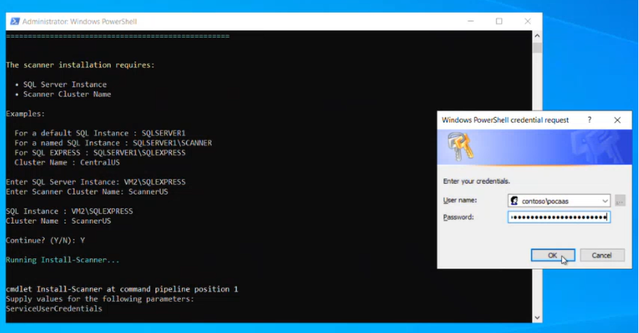
Figure 8. Enter the dedicated Log on Local Windows service account in the secure credential dialog.

- Wait for Install-Scanner to create the Windows service and the AIPScannerUL_<cluster> database.
- Confirm that the MIPScanner service is running and that the script reports successful completion.
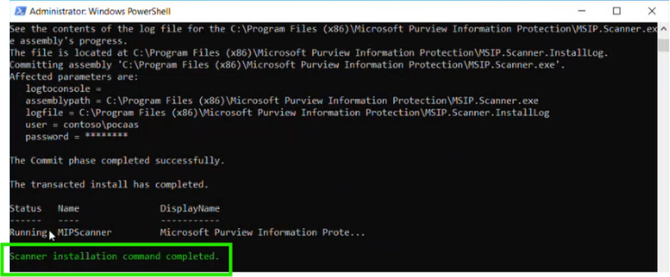
Figure 9. Example of a completed scanner installation and running service.
INSTALLATION PERMISSIONS
Install-Scanner requires local administrator rights on the scanner server and sysadmin rights on the selected SQL instance. The steady-state service account should not retain unnecessary SQL server-level elevation.

8 | Configure application authentication
The scanner must acquire a Microsoft Entra token before it can retrieve policy and operate. The companion script creates or reuses the scanner application, configures required permissions, requests admin consent, creates a client secret, and runs Set-Authentication.
- Confirm that the signed-in administrator is authorized to create app registrations, create credentials, and grant tenant-wide admin consent. If not, stop and coordinate with the identity administrator.
- Choose Y at the prerequisite prompt only when the required access has been confirmed.
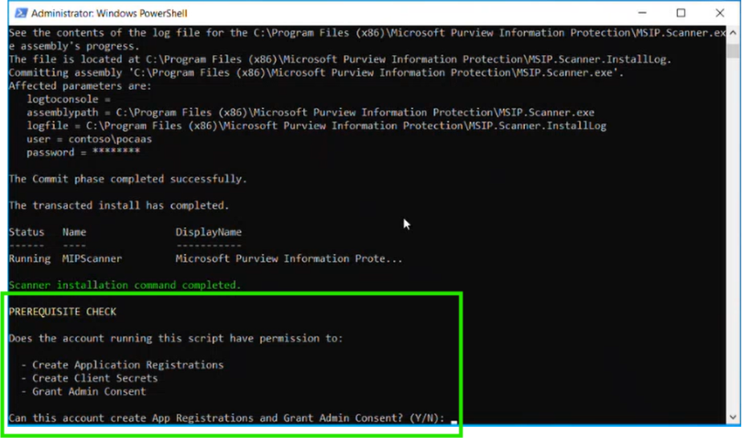
Figure 10. Administrative prerequisite check before app registration creation.
- Press Enter to connect to Microsoft Graph. If prompted to sign in to all apps and websites on the device, select No, sign in to this app only.
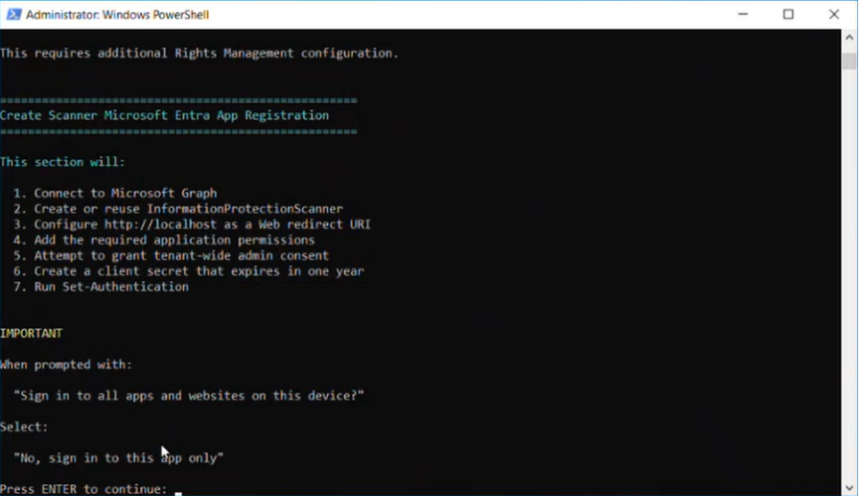
Figure 11. Use “No, sign in to this app only” if prompted.

9 | Optional Azure Rights Management super user
Select this option only when the scanner must inspect or process content that requires Azure Rights Management super user access and the use case has been approved. This configuration is separate from app-registration admin consent.
- At “Configure Super User support?”, choose Y to configure the additional permission, or N to skip the feature.
- If selected, sign in with an account authorized to administer Azure Rights Management
- Allow the script to verify or enable the super user feature and assign the delegated scanner account as a super user.
- Confirm that the script reports successful membership verification.
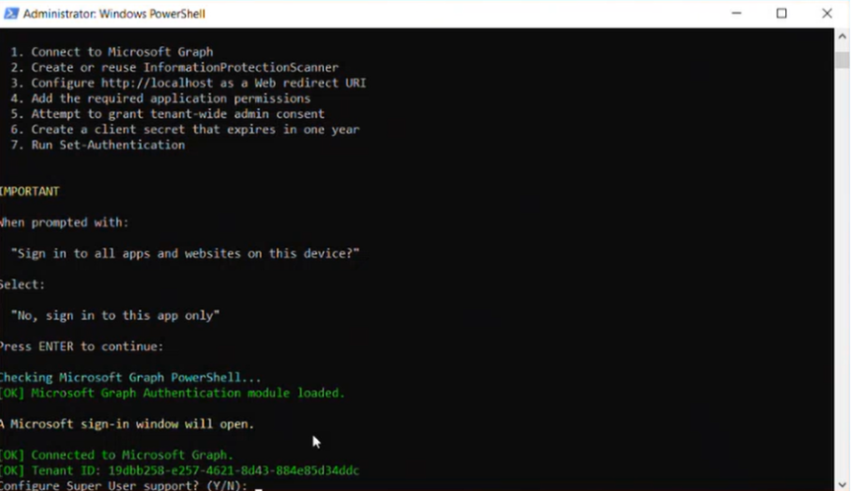
Figure 12. Before App Registration is created, choose the optional setting to create Super User API permission.

USE WITH CARE
Azure Rights Management super user access is highly privileged. Document the business reason, approval, account owner, and periodic review process.

- The App Registration Process will continue. When the client secret is displayed, store it immediately in the approved vault and record the owner and expiration date. The secret value is not shown again.
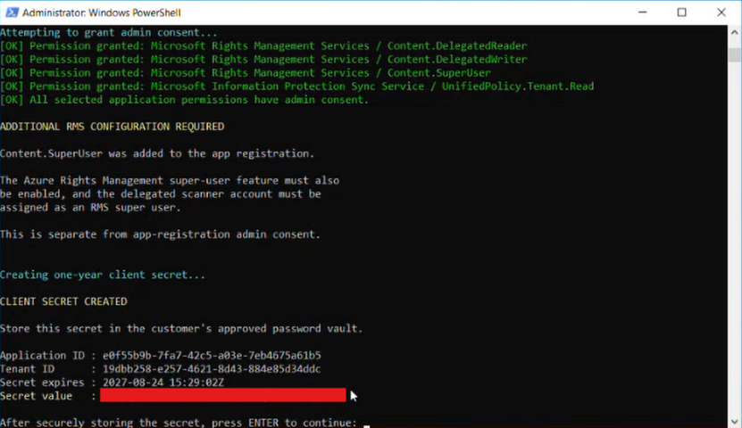
Figure 13. Store the generated client secret securely before continuing.
- Enter the Windows service account in DOMAIN\user format and the delegated scanner account UPN when prompted. These will be used during the Set-Authentication command process.
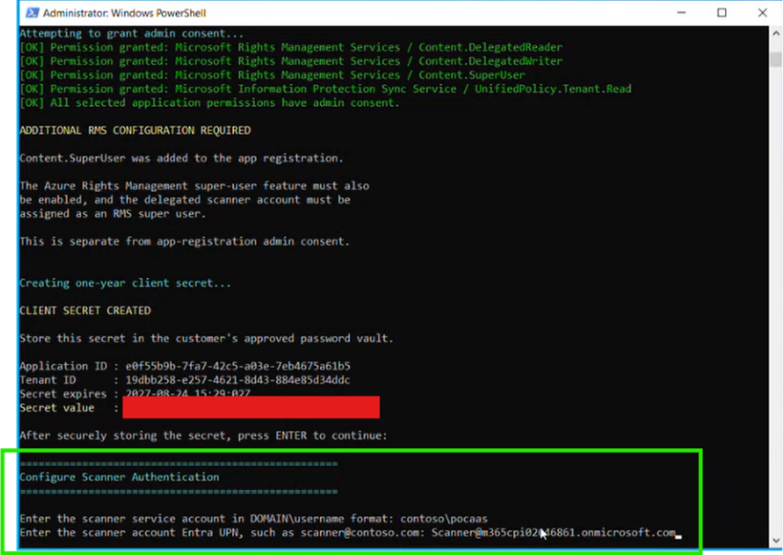
Figure 14. Enter Local Log on user account and Cloud service account to create Set-Authentication command.

- Confirm that Set-Authentication reports an acquired access token and successful completion.
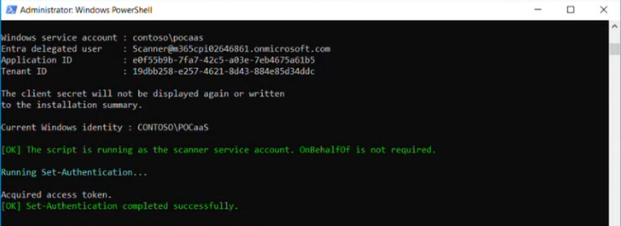
Figure 15. Confirm Set-Authentication command runs successfully.

- (Optional) Returning to the Super User role, if the “Y” option was selected earlier, this process will configure Azure RMS Super user. An account authorized to administer RMS will be needed. Press “ENTER” to continue.

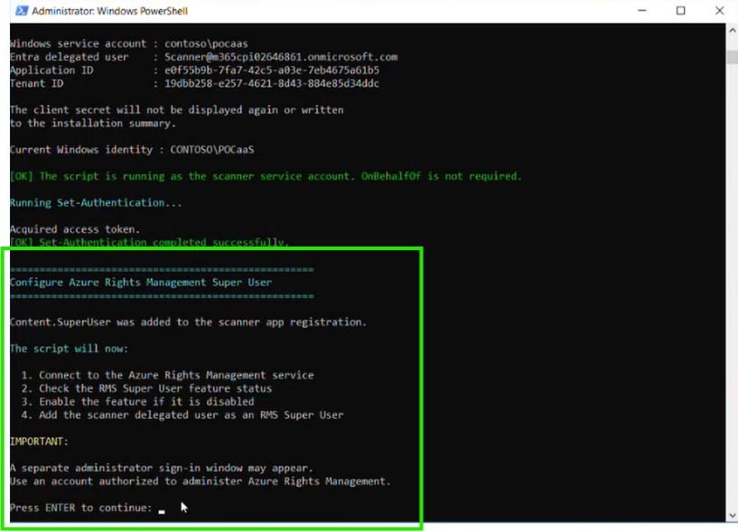
Figure 16. Assign membership of Super User role to Scanner Service Account. (If not configuring Super User, this can be done later.)
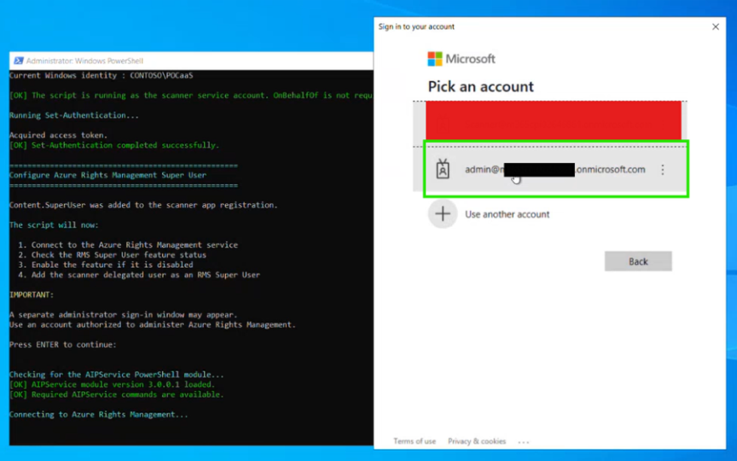
Figure 17. Connect to Rights Management Service with admin account.
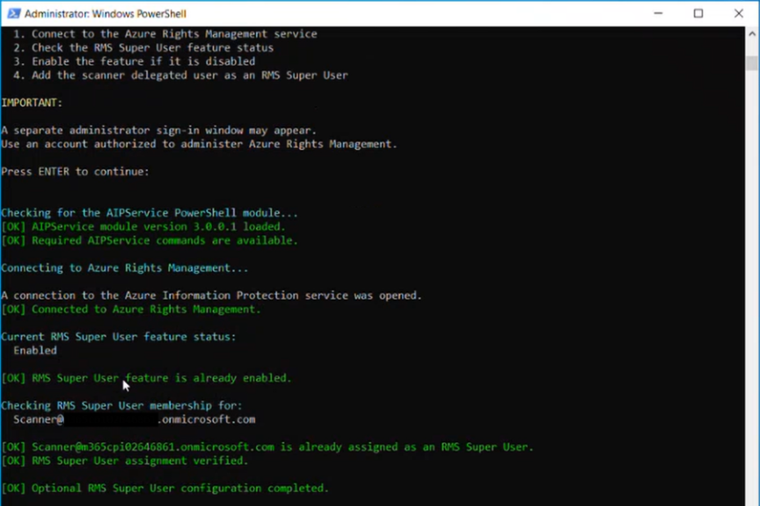
Figure 18. Confirmation of Scanner Service Account granted Super User role.

SECURITY CONTROL
Treat the client secret as a credential. If it is exposed in a transcript, screenshot, ticket, or chat, revoke it and create a new credential.

10 | Validate readiness and run the first scan
After authentication is complete, validate service health before scanning customer content.
Readiness commands
Get-Service MIPScanner
Get-ScannerConfiguration
Get-ScanStatus
Start-ScannerDiagnostics
  - The MIPScanner service should be Running.
  - The scanner configuration should reference the intended online configuration and cluster.
  - Get-ScanStatus should show an idle, non-scanning state before the first manual scan.
  - Start-ScannerDiagnostics should validate database access, required URLs, authentication, policy acquisition, profile configuration, and rule validity.
Start a discovery scan
Start-Scan (or “Start-Scan -reset” for full rescan)
Get-ScanStatus
Use Start-Scan -Reset only when a deliberate full rescan is required. The -Reset switch forces all files to be scanned again. Start-Scan is intended for a manual schedule; it is ignored when the schedule is set to Always.
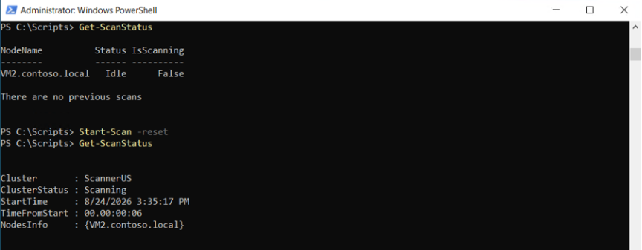
Figure 19. Validate that the scanner is ready to scan. Initiate first test scan.

PILOT FIRST
Run the initial cycle against a small, representative repository in discovery mode. Review errors, throughput, detections, exclusions, and report quality before expanding scope.

11 | Reporting, operations, and troubleshooting
Monitor and review reports
- In the Purview portal, open Information protection scanner > Content scan jobs, select the job, and refresh until Last scan results and Last scan end time are populated.
- Use Get-ScanStatus to monitor the same cycle from PowerShell.
- Review the local reports under %localappdata%\Microsoft\MSIP\Scanner\Reports. Summary_<x>.txt provides cycle-level totals; CSV reports provide per-file detail.
- Preserve historical local reports if the customer requires trending beyond the portal’s last-scan view.
ACTIVITY EXPLORER
Activity Explorer is relevant when the customer has configured supported Purview activity scenarios such as DLP for on-premises repositories and assigned the necessary roles. Do not treat it as a replacement for the scanner’s local reports.

Common validation failures
Symptom | Check first | Recommended action
Database access error | SQL login/user mapping, database owner, service identity, and service restart. | Correct the account mapping with the SQL administrator, restart MIPScanner, and rerun diagnostics.
Labels do not appear | Label policy publication and delegated account authentication. | Confirm the account is targeted, sign in again, and verify policy acquisition.
Authentication fails | App ID, tenant ID, credential validity, permissions, and admin consent. | Replace expired or exposed credentials and rerun Set-Authentication.
Repository access denied | Share and NTFS permissions; SharePoint permissions; path format. | Validate access while using the scanner service identity and keep the pilot read-only where possible.
Unexpected labeling | Enforce, relabel, recommended-as-automatic, repository overrides, and label conditions. | Stop the scan, return to discovery mode, correct policy or scope, and rerun the pilot.
Operational handoff checklist
☐ Service owner and escalation contact recorded
☐ App registration owner and client secret expiration tracked
☐ SQL backup, monitoring, and maintenance ownership documented
☐ Scanner log and report retention agreed
☐ Repository additions require change approval
☐ Discovery-to-enforcement approval recorded
☐ Runbook includes Start-ScannerDiagnostics and support log collection
☐ Quarterly review of service account, app permissions, and RMS super user membership scheduled

A | Appendix A: Command reference

Command | Purpose
Get-Service MIPScanner | Verify that the scanner Windows service is installed and running.
Get-ScannerConfiguration | Display the scanner’s local configuration settings.
Get-ScanStatus | Return scan status and node information.
Start-Scan | Start a one-time scan cycle when the schedule is manual.
Start-Scan -Reset | Force a full rescan of files. Use only with an approved operational reason.
Start-ScannerDiagnostics | Run scanner health checks and create diagnostic output.
Set-Authentication | Configure scanner/client authentication with the app registration, tenant, credential, and delegated account.
Set-ScannerDatabase | Change the scanner service account or SQL database configuration after installation.
Update-ScannerDatabase | Update the scanner database schema after a client upgrade using an account with db_owner on the scanner database.

B | Appendix B: Microsoft documentation
- Scanner prerequisites
- Configure and install the scanner
- Learn about the scanner
- Run and manage scans
- PurviewInformationProtection PowerShell module
- Install-Scanner reference
- Start-ScannerDiagnostics reference
- Information Protection client
SOURCE OF TRUTH
Microsoft Learn guidance and product behavior can change. Revalidate prerequisites, supported versions, permissions, and download links before each production deployment.

